New/Existing Projects

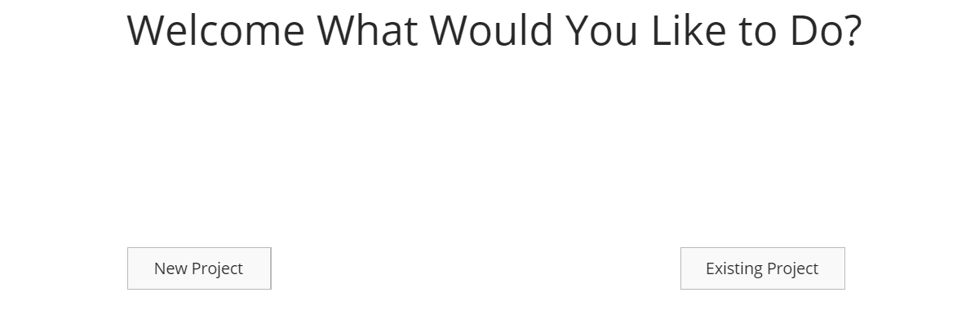

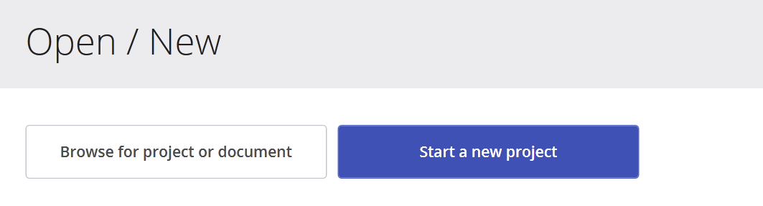

When initially opening the program a screen will show up asking the user if they would like to start a new project or use an existing project to continue using it. Each deliverable will also have their own new or use an existing project button if they need to create something.

**Deliverables**

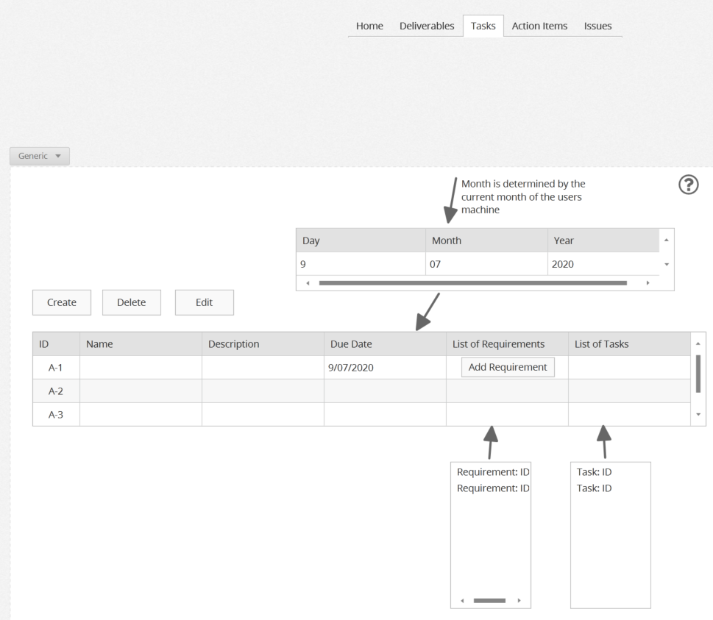

The program will be able to create deliverables and list the deliverables that are created. There will be a unique Identifier in the ID section that will be a number or alphanumeric string that is associated with each deliverable. The ID will be unique. The name will be an alpha numberic string to identify the deliverable. The description section is just a short description of the deliverable. The Due Date section will identify when the deliverable must be completed and delivered to the client. A pop up calendar will show up that will allow the user to choose a date that they want to choose. The month will start based on the month of the date object used by HTML. A requirements section will list the names and unique IDs of requirements associated with the Deliverable. The user can add a requirement with a click of a button.The user will manually select the requirement and Task that they want to associate with the deliverable. The list of tasks section is a list of Names and ID’s of tasks associated with the deliverable. A deliverable is paired with a task by getting the appropriate task ID from the server and displaying it on the list of tasks section.

**Issues**

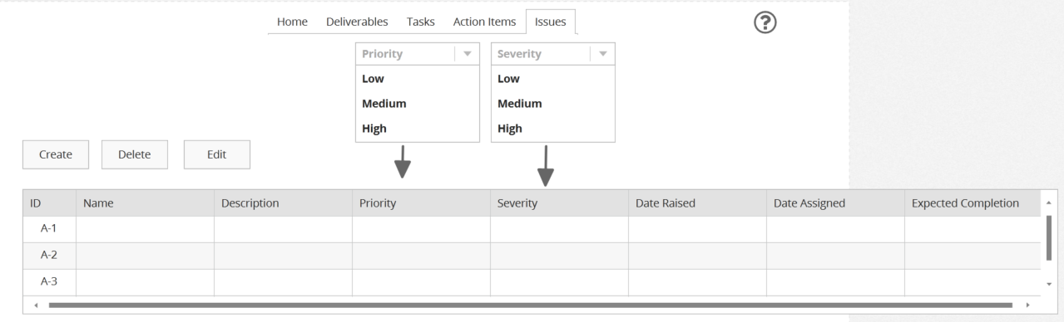

The issue screen will be a section where the project manager could add/delete/update issues. List the severity and priority level of the issue. It will also keep track of when the issue was created. It would have a small description of the issue. Unique identifier would be automatically generated for the issue. Date assumed to be completed would be added in the description. After the issue has been completed the issue would be marked with a checkmark. The priority and severity will pop up with their default lists of options as tabs that can be scrolled down for the convenience of the user. When the description is added or updated, the system will automatically store the date. A list of associated action items and decisions will pop up. The user can decide what Action Item they want to associate with an issue by clicky the Action item section which will make a list pop up with the available Action items that the user has placed which they can then choose and will display the action item ID and name. Decisions will be associated in the same way.

**Action Items**

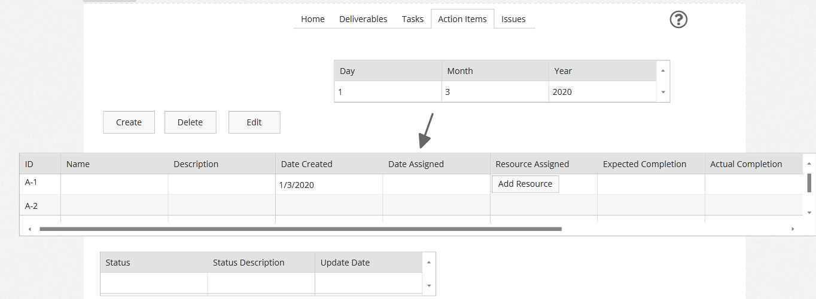

The action items screen will be a simple and clean experience. The project manager will be able to easily input their data into the table as shown above. They will also have access to the tabs at the top so that they can navigate to other sections of the program. To insert the dates the user will be able to select the Month, Day, and Year they would like to go to and then a calendar would pop up to help them select and end date. They will also be able to see an automatically set date of the last update they made set in place so that they can see the documentation they have done. Resources are assigned by the project manager when clicking on the Resource assigned task and a pull down window will appear with the different resources that are available to use. They will be able to add a resource with a click of a button.

**Tasks**

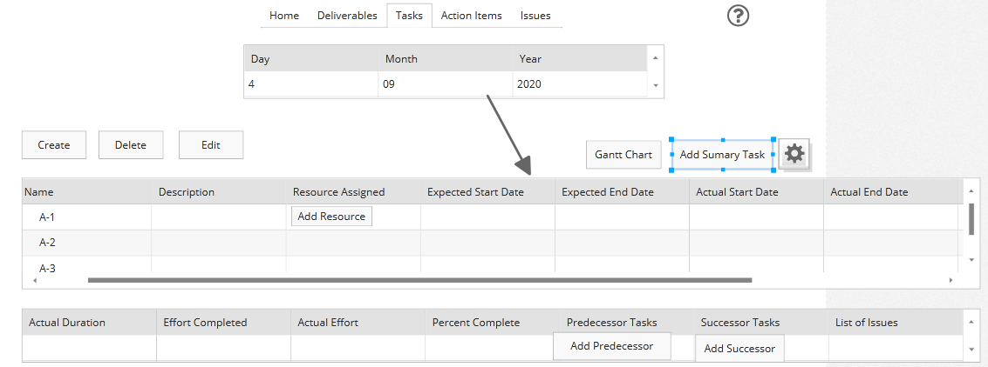

The Task Screen would be all data is saved in one file. Where the project manager would create/update/delete tasks. Dependent tasks would be marked in red and the system would not let you start on another task until you finished the dependent task because those would take priority. Then each are assigned to a resource along with an expected start and end date. These start and end date would all be saved and kept track of which would produce a graph schedule showing all the resources expected start and end dates. There would also be a countdown on how many days the worker would have left on the task they are currently working on. A unique identifier would be generated automatically and to make sure the identifier is unique and not currently being used. Name of task would be given by the project manager as well as the description and resource assigned. And when you would pick expected start date there would be a drop menu of all the months and date and year so you won’t have to continue clicking or scrolling through month by month. There is a button to add a successor and predecessor task. There will also be a button that will display a gantt chart. Predecessor and Successor Tasks are set by the user, a pop up box will show up that will allow them to select the tasks that will be the predecessor or successor. A resource is assigned manually by the user when they click on the resource section they will get a list of resources that they can choose to associate with a task. A user will have the option of choosing a Task and having the option to group it as a summary tasks through a button.